SARCASM DETECTION USING COMBINED BERT AND GRAPH CONVOLUTION NETWORKS
B Sai Abhishek, Balam Ruchith Balaji, Chillakuru Hari
Department of Computer Science and Engineering, Amrita School of Computing,
Bengaluru, Amrita Vishwa Vidyapeetham, India.
BL.EN.U4AIE21015@bl.students.amrita.edu, BL.EN.U4AIE21017@bl.students.amrita.edu,
BL.EN.U4AIE21038@bl.students.amrita.edu

Abstract— Sarcasm, which is a more elaborated language style that takes different attitude from what you say the straightforwardly, is a main problem in natural language comprehension. Sarcasm pervades these media as has been obvious from the piece of online communication we are going to study. Besides, literature review shows that this has drawn more attention to sarcasm detection as the use of internet and other online platforms has multiplied at an astronomical rate. Deep learning techniques have proved to be powerful tools that have been successfully availed to detect sarcasm over the years, through their capability of picking up several layers of intricate linguistic patterns and contextual clues. The article will deliver an in-depth examination of the latest deep learning techniques used for sarcasm detection. Techniques in this class are universal; they adopt an array of neural network architectures, including, but not limited to, transformer-based models, BERT and GCN.
Keywords— Sarcasm Detection, Deep Learning, Natural Language Understanding, Sentiment Analysis, Neural Network Architectures, BERT, GCN

Introduction
Sarcasm represents the most technical manner of using the language during informal circumstances, social media chats, and internet communication channels. It commonly seems like the intention of the author is sometimes in opposition to the actual meaning. For natural language imperative activities like sentiment foresee, opinion mining, and dialogue systems, recognizing sarcasm will be of paramount importance because it has a major effect on how text will be understood and the emotion that will be expressed. Although sarcastic expressions are a typical part of human interactions, machine learning systems find it difficult due to the complexity, default of the expressions and the context sensitivity.
Sarcasm is certainly hard to uncover by natural language processing since it contains numerous linguistic resources and notions of both speech and content. Natural language processing develops from its revolution of recent years where deep learning techniques, allow models to be able to learn the patterns and functionality already from the data. These deep learning algorithms interest because of their capability of managing large number of context input in a complex way to catch intricate relationships.
The goal of this work is to accomplish an in-depth investigation of the latest techniques, potential and issues in the field of sarcasm detection using deep learning. This is done by way of summarizing the whole themes. We are into a great deal to understand and develop customized neural network structure that are more effective in sarcasm detection by using transformer – based models, BERT and GCN. Furthermore, we emphasize the issues with datasets, transporting meaning from one context to another, and text pre-processing which are the prerequisites to build a better sarcasm detector.
Another important section in the paper is Altenative Approaches on Data Sarcasm Detection, including the specific treatments for data sparsity, domain appropriability, and culture variances. Sarcasm detection systems have been useful in solving some problems but to excel further, we also assess the indicators employed to measure the systems' performance and note areas that need thorough investigation.

Literature Review
Mayank Shrivastava Et al [1]. The research is dedicated to the sarcasm that occurs in case of text-based communication whose processing is made by the new machine learning model preserving the issues of huge data volume, high velocity, and abnormal data distribution. A model is shown as a classical approach and a temporary one, and is given precision rate, recall, F1 score and accuracy. That is, one of the mission is to help create a safe ones and well-analytical social environment, as the internet has transformed the world into a virtual village, where information-sharing platforms like Twitter and Facebook have changed text-based information to visual data online.

Ibrahim Abu-Farha Et al [2]. It has been made by the authors by using sentiment analysis datasets available in advance and called as AR Sarcasm. Among the 11k tweets with sentiment labels, 16% of them are sarcastic. The analysis reveals that the mechanism of sentiment analysis is not objective. They alter as per the biases of the individual annotator. Sentiment analysis tests shows that when exposed to sarcasm the performance even best of the intelligence analyzers degrades. BiLSTM deep learning model would provide 0. as the F1-score. 46.

D. Vinoth Et al [3]. The introductory section of the paper offers an (integrated machine learning-based semantic dictionary compilation) technique using the features of classification, feature selection, feature engineering, preprocessing, and parameter tuning. The sarcasm detection becomes an increasingly important challenge on network sites as the number of internet users continuously increase. It provide: (TF-IDF) for feature engineering and chi-square and information gain as feature-selection approaches. The applies SVM as the kernel function and obtains optimum values of C through PSO. Experiments show promising performance.

. Avinash Kumar Et al [4]. Additionally, it is evident that BiLSTM models demonstrate a higher efficiency over feature heavy SVM technique. Instead, it has found the sarcasm comments something much more effective than the old ones. Sarcasm detection is a crucial in sentiment analysis as a result of the wily negativity conveyed on social media by using promising or jumping language. Despite sarcastic remarks being had predicted, a model called middleware heavy attack (MHA-BiLSTM) network is introduced.

Samer Muthana Sarsam Et al [5]. The research defines the usage of machine learning algorithms for detecting sarcastic posts on social networks, limiting its area of interest to Twitter. The reviewers used the PRISMA statement to evaluate the methods that were applied by ML algorithms. According to the analysis the Support Vector Machine (SVM) was commonly used for sarcastic detection and this together with the combination of Convolutional Neural Network (CNN) is totally justified by the achieved high accuracy of predictions. The study offers solutions to problems which the previous researchers faced in predicting sarcastic tweets, a knowledge that is crucial for the scholars which will come in future and those who are developing machine learning systems.

Aparna K Ajayan Et al [6]. The paper presents a classification problem which allows to detect sarcasm by using machine learning algorithms such as K-Nearest Neighbor, SVM, NB, Decision Tree, Logistic Regression, Random Forest ensemble to identify class imbalance issues.

K. Sree Lakshmi Et al [7]. This study investigates the efficiency of multilingual transformer-based embedding series in recognition of hate, angry, and critic contents in social media takes by Codemix. The models encoded in the experiment are observed to have the highest accuracy with six datasets and also introduce a newly annotated test data for Malayalam-English Codemix.

Venkatesh B Et al [8]. An Innovative Technique for Soft Tissue Regeneration,” identified PRP as a biomimetic approach for soft tissue regeneration. This work introduces a hybrid machine learning approach which stems out to identify the ironic speech originating at Twitter sent in short terms in the title data coming from social media and microblogging platforms Research methodology which relies on the usage of corpus linguistics, natural language processing, Bag of words, sentiment analysis, K Nearest Neighbors (KNN), Machine learning, Generalization, Anomaly detection, Binary class and Logistic Regression model belonging to Random Forest.
R Prasanna Kumar Et al [9]. Using machine learning that also embraces neural network methods, sarcastic tweets written in both Tamil and Telugu languages will be selected. Concentrating farmers on use of a few data sets the main goal is to bridge out the language gaps. This smart meter combines smart features due to it has the accuracy rate of 95%. 68% and 95. On the one hand, 37% is there for the sarcasm use in spoken language at small scale, meantime, the latter percentage, forecasted to be about 15% would definitely need dig down to the truth on sarcasm is and how it works in our normal lives.

Santosh Kumar Bharti Et al [10]. August paper suggests a new method that takes in both written and audio features to detect the sarcasm when conversing people in one on the other in a two way friendly conversation, having in mind, that individual models present exclusive faults and audio is not everywhere for use.

Research Gaps:

Most of the sarcasm detection models out there have been trained on English data that was collected to the greatest on by social media sites like Twitter. Our gap is in the arc of sarcasm’s detection studies in other languages and multi-contexts of cultures. Current academic studies on sarcastic data usually form it as a binary classification matter (sarcastic vs. non-sarcastic). But, it's not just sarcastic quips that make us laugh, it's also irony, satire, or parody. A more diversified methodology is due to distinguish and find the differing types of the sarcastic approach.

It is not easy to measure thoroughly the success of humor and satire recognition models due to the absence of widely adopted evaluation metrics. Alongside this, creating detailed evaluation methodologies and metrics for the purposes of fair comparison between different models and creating accurate progress charts are all important steps in the field.

Methods and Materials
Dataset:
The contents of the dataset are given below:
riloff: It contains an unbalanced set of sarcastic and non-sarcastic tweets.
Headlines: It contains news headlines on sarcastic sources.

Corpus | Train Set |  | Test Set
Corpus | Sarcastic | Non-Sarcastic | Sarcastic | Non-sarcastic
riloff | 215 | 1,153 | 93 | 495
headlines | 2516 | 2504 | 570 | 410

Methodology

Bidirectional Encoder Representations from Transformers (BERT)
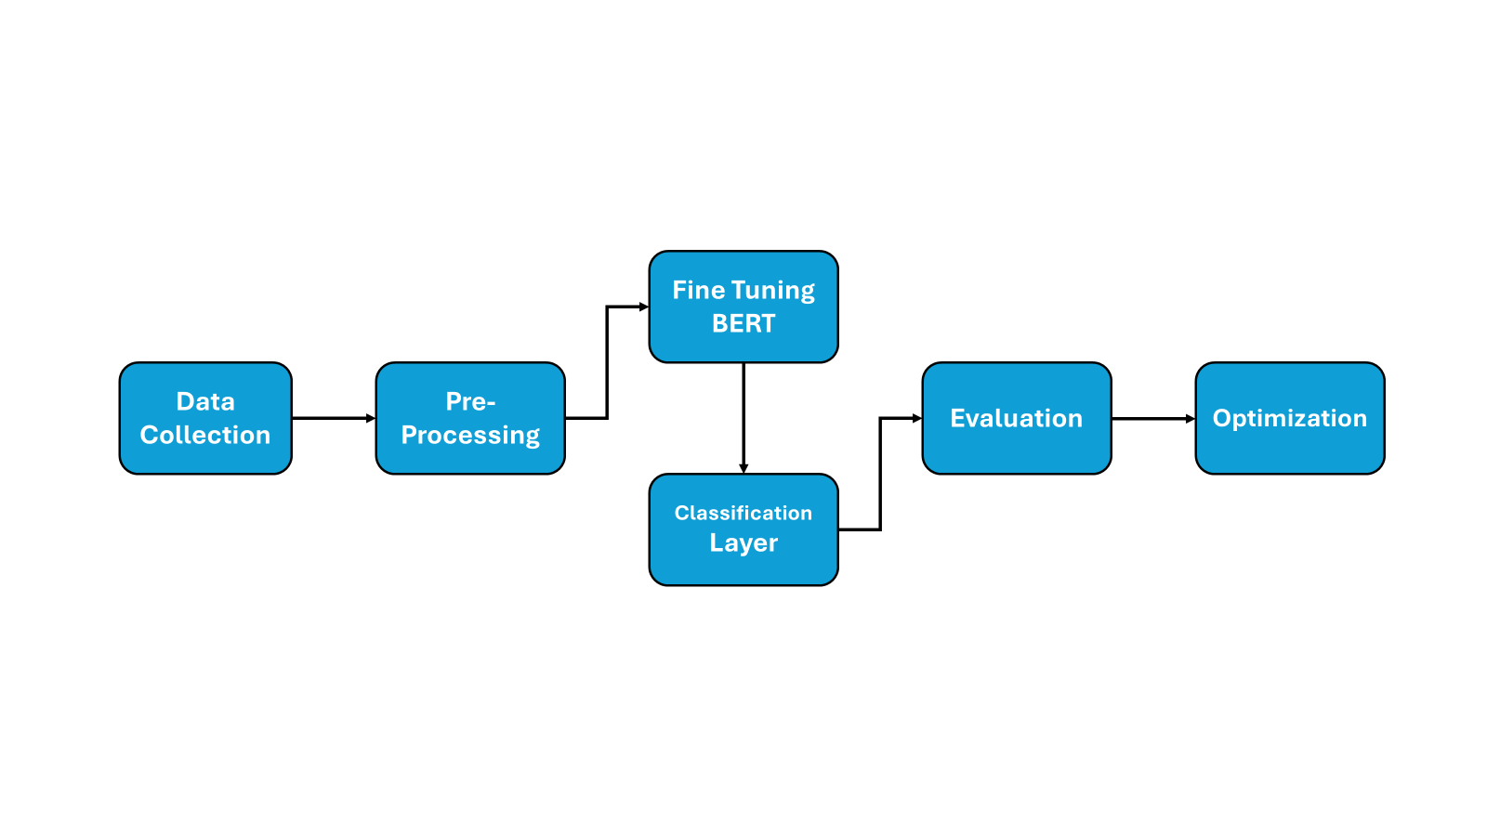
Fig-1 Flow Diagram of Sarcasm Detection of text data using BERT (Bidirectional Encoder Representations from Transformers)

The detections of sarcasm in BERT are accomplished in few steps. At first, all tokens are tokenized and vectorized. Then the words receive representations that are numeric and applicable to BERT. Finally, BERT gets fine-tuned on a dataset which contains the sarcasm, with adjusting the parameters of it particularly for this task. Sentence embeddings will take third-dimension outputs of BERT's last layer for each token in the input sequence. To determine sarcasm, an extra classification layer was introduced and also trained in parallel with BERT. The superseding the model `level of performance is assessed using like F1 score, precision, recall, and accuracy on a separate data set. Trial and error involved in the adjustments of hyperparameters such as learning rate, batch size, and epochs is required for optimization. Ultimately, thresholding or ensemble ways may be applied for the post-processing of the model for the additional refining, if needed.

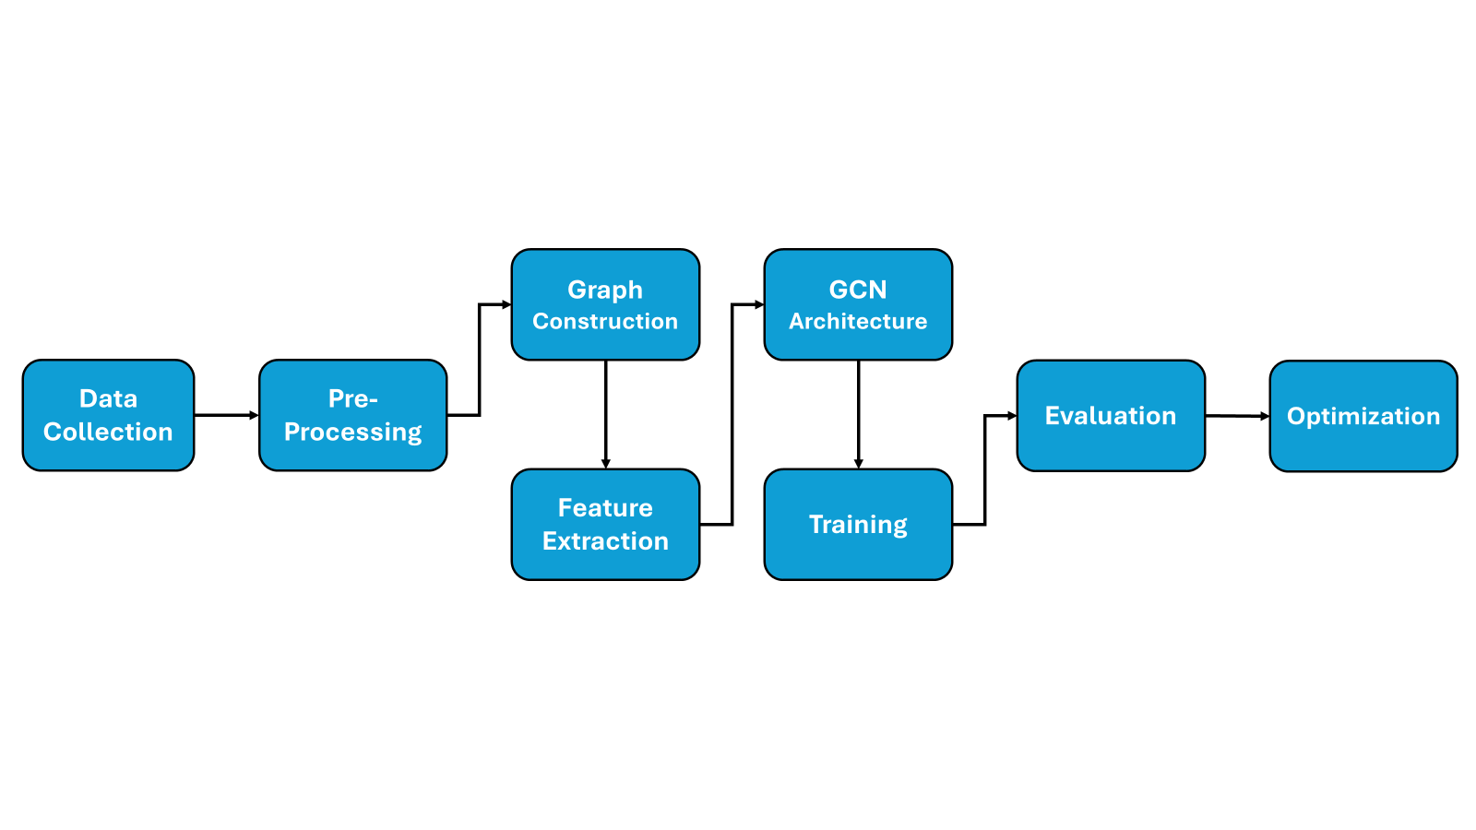
Graphical Convolution Networks (GCN)

Fig-2 Flow Diagram of Sarcasm Detection of text data using GCN (Graphical Convolution Networks)

The GCNs can detect sarcasm with two steps such as building and preprocessing the data, for instance, having non-sarcastic and sarcastic text data composed in a graph model where nodes are words for each token and connecting them by edges like co-occurrence or syntactic links. Extract the characteristics like word embeddings from the text data, which is the main layer in the structure of the GCN architecture with the input of multiple graph convolutional operations and proper activation functions. Separate the cluster into training, validation, and test sets, run the GCN model using optimization techniques like SGD and Adam, and control training on the validation sets to prevent overfitting. By means of indicators find out how the model is working on the test set against the benchmark ones. Iterate the process with the help of fine-tuning hyperparameters, architectures, or features and put online for sarcasm detection in real world applications, checking by monitoring its result. In case the updates are needed, apply the changes for further effectiveness.

BERT and GCN:

Feature Extraction:
Taking the text tokens as parameter, we generated contextualized word embeddings based on BERT. Humanized competition via BERT is demonstrated by unique contextual representations that adequately convey words within context. Moreover, for each node we calculated the node-level features like (degree of node, further graph-based features that might capture semantic relationships) from graph structures.

Graph Construction:
By making our graph structure on a preprocessed text data that will represent word or tokens as nodes while syntactic relationship or semantic connections will be represented by edges. There are various linguistic characteristics which can be used to construct the graph e.g. dependency parsing, co-occurrence statistics or semantic similarity measures.

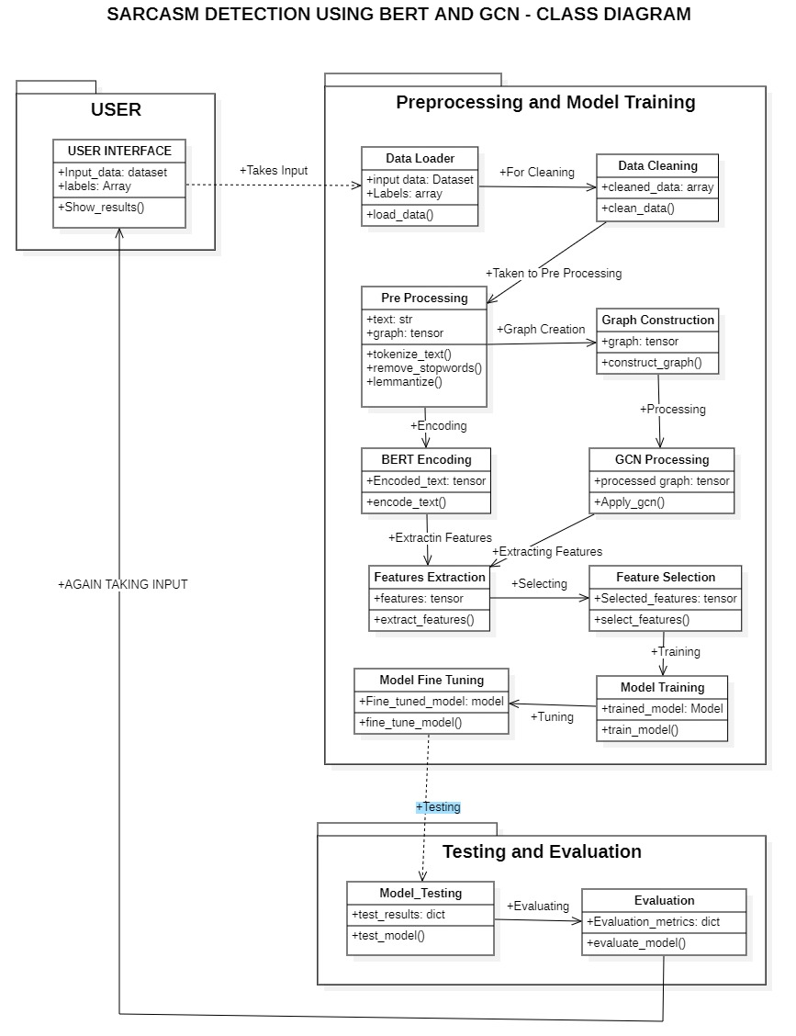

Fig-3 Class Diagram of the Sarcasm detection using combined BERT and GCN, it contains 3 sections of User side, Preprocessing and Training, Testing and Evaluation

We will do this by using our edge structure based on initially preprocessed text data representing words or tokens as nodes, and their syntax-based relations or semantic connections as edges. Different language-specific linguistic traits can be applied to the construction of the graphs like e. g. dependency parsing, co-occurrence statistics or semantic similarity measures.
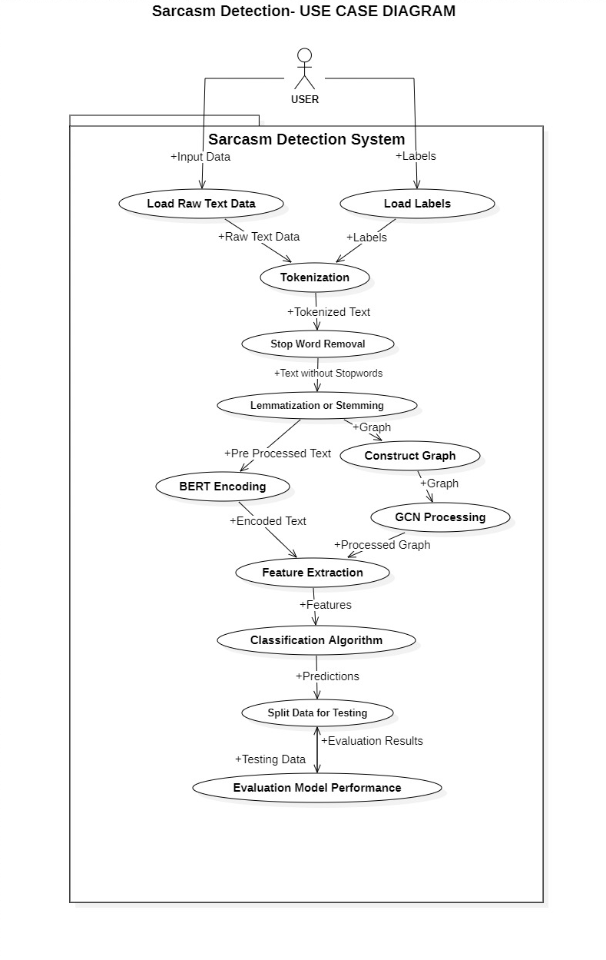
Fig-4 Use Case Diagram of the Sarcasm detection using combined BERT and GCN, It contains 10 stages of User side, Preprocessing and Training, Testing and Evaluation

Graph Convolutional Network (GCN):
The precision of the finale chart is directly correlated with the graph of GCN that is used. Therefore, they provide data to the neighboring nodes through the usage of several form of network layers. By this, they create GCNN (graph convolutional networks). The task of word embeddings was not the only that the network could perform.

Integration of BERT and GCN:
Came to the main point to copy the advantageous part of the GCN and BERT information, we concatenated the node-level features, in other words, the GCN has learned with the BERT embeddings. The embedding can be provided to the classifier as different inputs for the BERT, at the same time, as additional features for the GCN, which is placed at the end of the BERT output.

Results

Model | Accuracy | Precision | Recall | F1-Score
BERT+GCN | 99.28 | 96.57 | 95.89 | 87.85

Model | Loss | Val Accuracy | Val F1-Score | Val Loss
BERT+GCN | 0.0297 | 97.57 | 85.11 | 0.025

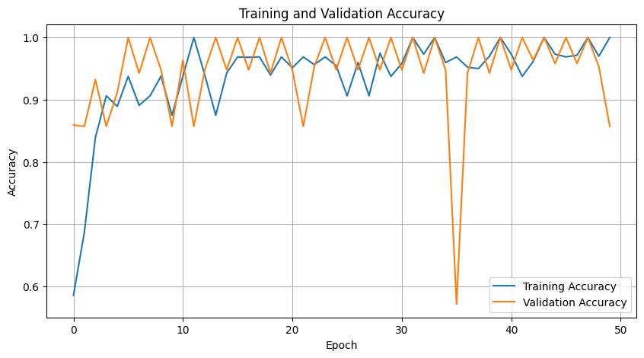
Fig-5 Validation Accuracy and Training Accuracy Obtained for 50 Epochs

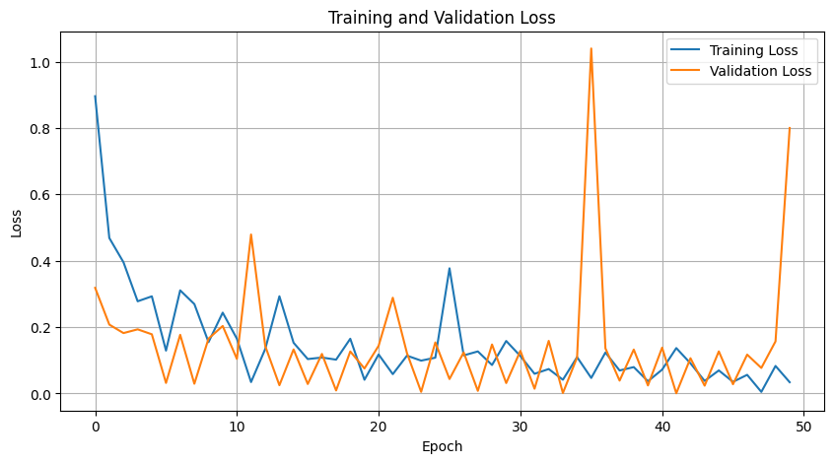
Fig-6 Validation Loss and Training Loss Obtained for 50 Epochs

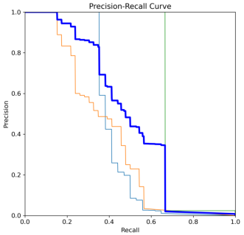
Fig-7 Precision Recall Curve- shows the relationship between precision and recall at different threshold. A high area under the curve represents both high recall and high precision, where high precision relates to a low false positive rate, and high recall relates to a low false negative rate.
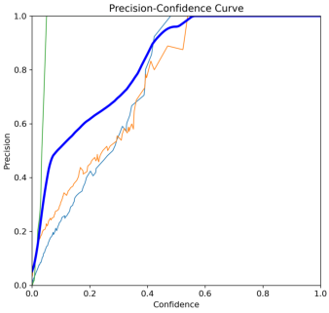
Fig-8 Precision confidence Curve-plots precision against different confidence thresholds. It helps to understand how precision changes as the confidence level is adjusted for classifying a prediction as positive.

Conclusion

Unlike other methods in literature, the BERT+GCN model exhibits a satisfactory performance in the field of sarcasm detection, as analyzed by the results of the training and validation with high ability metrics. Consequently, an architecture with semantic properties harnessing GCN channels and with contextualization built on top of BERT accounting for meaning is one that is exceptionally performant. Besides this, it has indeed proved to have been useful for the automated sarcasm detection tasks in a big number of applications, such as social media sentiment analysis and customer feedback analysis. It is still doing a good job of ensuring high classification rate and generalization performance despite new tasks. However, standards of test that are set may require more analysis which would revolve around the directives and specifications on how these standardized tests could evaluate the different domains and the language used and at what specific level it does.

References
- Shrivastava, M. and Kumar, S., 2021. A pragmatic and intelligent model for sarcasm detection in social media text. Technology in Society, 64, p.101489.
- Farha, I.A. and Magdy, W., 2020, May. From arabic sentiment analysis to sarcasm detection: The arsarcasm dataset. In Proceedings of the 4th Workshop on Open-Source Arabic Corpora and Processing Tools, with a Shared Task on Offensive Language Detection (pp. 32-39).
- Vinoth, D. and Prabhavathy, P., 2022. An intelligent machine learning-based sarcasm detection and classification model on social networks. The Journal of Supercomputing, 78(8), pp.10575-10594.
- Kumar, A., Narapareddy, V.T., Srikanth, V.A., Malapati, A. and Neti, L.B.M., 2020. Sarcasm detection using multi-head attention based bidirectional LSTM. Ieee Access, 8, pp.6388-6397.
- Sarsam, S.M., Al-Samarraie, H., Alzahrani, A.I. and Wright, B., 2020. Sarcasm detection using machine learning algorithms in Twitter: A systematic review. International Journal of Market Research, 62(5), pp.578-598.
- Ajayan, A.K., Mohanan, K., Anugraha, S., Premjith, B. and Kp, S., 2022, July. Amrita_CEN at SemEval-2022 Task 6: A Machine Learning Approach for Detecting Intended Sarcasm using Oversampling. In Proceedings of the 16th International Workshop on Semantic Evaluation (SemEval-2022) (pp. 834-839).
- Sreelakshmi, K., Premjith, B., Chakravarthi, B.R. and Soman, K.P., 2024. Detection of Hate Speech and Offensive Language CodeMix Text in Dravidian Languages using Cost-Sensitive Learning Approach. IEEE Access.
- Venkatesh, B. and Vishwas, H.N., 2021, September. Real time sarcasm detection on twitter using ensemble methods. In 2021 Third International Conference on Inventive Research in Computing Applications (ICIRCA) (pp. 1292-1297). IEEE.
- Kumar, R.P., Mohan, G.B., Kakarla, Y., Jayaprakash, S.L., Sindhu, K.G., Chaitanya, T.V.S.S., Ganesh, B. and Krishna, N.H., 2023, July. Sarcasm Detection in Telugu and Tamil: An Exploration of Machine Learning and Deep Neural Networks. In 2023 14th International Conference on Computing Communication and Networking Technologies (ICCCNT) (pp. 1-7). IEEE.
- Bharti, S.K., Gupta, R.K., Shukla, P.K., Hatamleh, W.A., Tarazi, H. and Nuagah, S.J., 2022. Multimodal sarcasm detection: a deep learning approach. Wireless Communications and Mobile Computing, 2022, pp.1-10.

